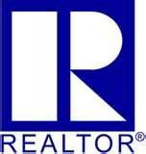
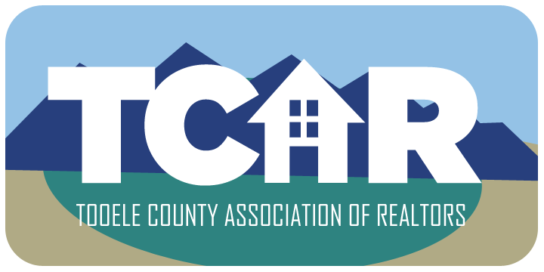
Tooele County Association of
REALTORS®
The voice of Real Estate in Tooele County
50 S. Main
Tooele, UT 84074
435-882-7444; Fax 435-882-7445

REALTOR MEMBERSHIP APPLICATION FORM

LEGAL NAME:_________________________________________________________________________________

PRIMARY BOARD______________________________________________________________________________

NRDS# (If assigned by previous Board):________________________BIRTH DATE:________________________

NAR CODE OF ETHICS DATE (last date of completion):_____________________________________________

NAR DESIGNATIONS:__________________________________________________________________________

HOME ADDRESS:______________________________________________________________________________

CITY:______________________________________________STATE:________________ZIP:________________

HOME PHONE:_________________________________ CELL PHONE:________________________________

EMAIL ADDRESS:______________________________________________________________________________

REAL ESTATE LICENSE#:___________________________________ DATE EXPIRES:___________________

COMPANY NAME:_____________________________________________________________________________

COMPANY ADDRESS:__________________________________________________________________________

CITY:_______________________________________________STATE:_______________ZIP:________________

COMPANY PHONE:____________________________ COMPANY FAX:________________________________

BROKER’S SIGNATURE:______________________________ NAME PRINTED:_________________________

I, the undersigned, hereby apply for REALTOR® Membership in the Tooele County Association of REALTORS®. I agree as a condition of
membership to complete the TCAR New Member Orientation within 90 days of joining and the NAR Code of Ethics training within 30 days of joining; and to thoroughly familiarize myself with the Code of Ethics of the NATIONAL ASSOCIATION OF REALTORS®, and the Bylaws of the Board, the Utah Association of REALTORS® and the National Association. I acknowledge that failure to complete the Orientation and the Code of Ethics training by the specified time allowed will result in my termination of membership and I will forfeit my dues and application fee. I further agree that my act of paying dues shall evidence my understanding and initial and continuing commitment to abide by the aforementioned Code of Ethics and Bylaws as from time to time amended. Applicant acknowledges that if accepted as a member and he/she subsequently resigns from the association or otherwise caused membership to terminate with an ethics complaint pending, that Board of Directors may condition renewal of membership upon applicant’s certification that he/she will submit to the pending ethics proceeding and will abide by the decision of the hearing panel.
If applicant resigns from the Association or otherwise causes membership to terminate, the duty to arbitration continues in effect even after membership lapses or is terminated, provided the dispute arose while applicant was a REALTOR®. I irrevocably waive all claims against TCAR or any of its officers, directors, members or staff, for any act in connection with the business of the Association, and particularly as to its or their acts in electing or failure to elect, advancing, suspending, expelling, or otherwise disciplining me as an applicant, or as a member. Upon the expiration of said membership for any cause, I will discontinue the use of the term “REALTOR®” and return to the Association all certificates, signs, seals or other indications of membership in the Association, the Utah Association of REALTORS® and the NATIONAL ASSOCIATION OF REALTORS®, and any other property of the Association in my possession.

AGENT SIGNATURE:_________________________________________________ DATE:_____________________

